A Major project Report on

AUTOMATED CAREER COUNSELLING USING RANDOM FOREST ALGORITHM

A project report submitted to

JAWAHARLAL NEHRU TECHNOLOGICAL UNIVERSITY, ANANTAPUR
In partial fulfillment of the requirements
for the award of the degree of
BACHELOR OF TECHNOLOGY
IN
COMPUTER SCIENCE AND ENGINEERING
Submitted by
Ⅳ B. Tech ІІ Semester
S. NAZIYA 213H1A0551
S. RUBEENA 213H1A0552
S. SAKEENA FARHAD 213H1A0553
S. BEBE HAJEERA 213H1A0548
G. CHINNI 213H1A0520

Under the Esteemed Guidance of
SMT. S. NAFEESA THEHSEEN,M.Tech.,(Ph.D)
ASSISTANT PROFESSOR,Dept . of CSE


Department of Computer Science and Engineering
K.L.M College of Engineering For Women
(Affiliated to JNTUA, Anantapuramu and Approved by AICTE, New Delhi) Tkadapa-516003.

(2021-2025)

Department of Computer Science and Engineering

KLM COLLEGE OF ENGINEERING FOR WOMEN
Approved by AICTE, New Delhi, Affiliated to JNTUA, Anantapur
Tadigotla (v), Kadapa-516003

Department of Computer Science and Engineering

Vision:

To produce high quality engineering professional with social responsibility to meet the needs of the industry and research in the area of computer science and engineering.

Mission:

- Ensuring effective teaching and learning process to facilitate student centric learning.

- Enhancing overall personality development to promote entrepreneur skills, communication skills and employability.

- Education women with professional ethics and human values to overcome challenges in professional career

Project report submitted in partial fulfillment of the requirement for the award of the Degree of B. Tech in Computer Science and Engineering

By

S. NAZIYA 213H1A0551
S. RUBEENA 213H1A0552

S. SAKEENA FARHAD 213H1A0553

S. BEBE HAJEERA 213H1A0548

G. CHINNI 213H1A0520

Under the Esteemed Guidance of
SMT. S. NAFEESA THEHSEEN, M .Tech.,(Ph.D)
ASSISTANT PROFESSOR, Dept. of CSE

Department of Computer Science and Engineering
KLM COLLEGE OF ENGINEERING FOR WOMEN
Approved by AICTE, New Delhi, Affiliated to
JNTUA,Anantapuramu
Website:www.klmcew.ac.in

KLM College of Engineering For Women
(Affiliated to JNTUA, Anantapuramu and Approved by AICTE, New Delhi)
Kadapa-516003.

Department of Computer Science and Engineering

Certificate
This is to certify that the project work entitled

Automated Career Counselling using Random Forest Algorithm
is the bonafide work done by

S. NAZIYA 213H1A0551

S. RUBEENA 213H1A0552

S. SAKEENA FARHAD 213H1A0553

S. BEBE HAJEERA 213H1A0548

G. CHINNI 213H1A0520

In the Department of Computer Science and Engineering,KLM College of Engineering For Women, Kadapa is affiliated to JNTUA-Anantapur in partial fulfillment of the requirements for the award of Bachelor of Technology in Computer Science and Engineering during 2021-2025.
This work has been carried out under my guidance and supervision.

The results embodied in this Project report have not been submitted in any University or Organization for the award of any degree or diploma.

INTERNAL GUIDE HEAD OF THE DEPARTMENT
SMT.S.NAFEESA THEHSEEN, M. Tech.,(Ph.D) Mr. D. SREENIVASULU, M. Tech.,(Ph.D)
Assistant Professor ,Dept. of CSE Assistant Professor & HoD

Submitted for University Examination(Viva Voice)held on _________________________

INTERNAL EXAMINER EXTERNAL EXAMINER

We are extremely thankful to our beloved chairman and establisher, Dr. K. CHANDRA OBUL REDDY Managing Director, Kandula Group Of Institution,for providing necessary infrastructure and resources for the accomplishment of our project at KLM College of Engineering For Women, Kadapa.

We are highly indebted to Dr. V. RATHNAMMA, Principal of KLM College of Engineering For Women, Kadapa, for his support during the tenure of the project.

We are very much obliged to our beloved Mr. D. Sreenivasulu, Head of the Department of Computer Science & Engineering ,KLM College of Engineering For Women for providing the opportunity to undertake this project and encouragement in completion of this project.

We here by wish to express deep sense of gratitude to Mr. D. Sreenivasulu, Department of Computer Science and Engineering, KLM College of Engineering For Women for the esteemed guidance, moral support and invaluable advice provided by him for the success of the project.

We are also thankful to all the staff members of Computer Science and Engineering department who have co-operated in making our project a success. We would like to thank all our parents and friends who extended their help, encouragement and moral support either directly or indirectly in our project work.

Thanks for Your Valuable Guidance and kind support.

DECLARATION

We hereby declare that project report entitled AUTOMATED CAREER COUNSELLING USING RANDOM FOREST ALGORITHM is a genuine project work carried out by us, in B. Tech (Computer Science and Engineering) degree course of JAWAHARLAL NEHRU TECHNOLOGICAL UNIVERSITY ANANTAPUR and has not been
submitted to any other courses or University for award of any degree by us.

Signature of the Student
- S. RUBEENA

- S. SAKEENA FARHAD

- S. BEBE HAJEERA

- S. NAZIYA

- G. CHINNI

ABSTRACT

Choosing the right career is a pivotal milestone in a student’s life and often shapes their future professional trajectory. Traditional career counselling, though valuable, can be influenced by subjective opinions and limited by human bias, accessibility, or lack of data-driven insights. To address this challenge, this project introduces an Automated Career Counselling System that leverages machine learning to provide personalized career recommendations. By analysing a student's academic background, practical experience, and soft skills, the system predicts optimal career paths using a trained Random Forest Classifier. Key inputs include GPA, internships, completed projects, communication skills, and other personal competencies.
The model was built using Python, with the scikit-learn library for machine learning and Flask for developing a lightweight and responsive web application. The user interface is designed to be intuitive and accessible, allowing students to interact easily with the system and receive actionable insights. The training data consists of a labelled dataset that maps various student profiles to corresponding suitable careers. After training and evaluation, the model demonstrated promising accuracy, confirming its reliability in assisting career decisions.
Unlike conventional guidance methods, this system offers a consistent and objective evaluation of students' potential career options. By removing human subjectivity, it ensures that each recommendation is solely based on data and measurable factors, making it suitable for large-scale deployment across educational institutions. Counsellors and administrators can use this system to support a growing student base with consistent quality and efficiency.
Looking ahead, the system has strong potential for further enhancement. Integrating real-time labour market data and trends could allow the platform to recommend careers based not only on student profiles but also on current industry demands. Additionally, incorporating automated resume analysis and natural language processing for evaluating written inputs or essays could significantly improve the personalization of suggestions. With these upgrades, the platform could evolve into a comprehensive career advisory ecosystem, aligning individual potential with dynamic professional landscapes.

LIST OF FIGURES

Figure No. | Description | Page No.
3.1 | Flow Chart for Proposed System | 12
3.2 | Architecture | 14
5.1 | Use Case Diagram for System & User | 19
5.2 | Class Diagram | 20
5.3 | Sequence Diagram for User & System | 21
5.4 | Collaboration Diagram | 22
5.5 | Deployment Diagram | 23
5.6 | Activity Diagram | 24
5.7 | Component Diagram | 25
5.8 | ER Diagram | 26
5.9 | Data Flow Diagrams | 27

FIGURE NO. DESCRIPTION PAGE NO
9.1 Running Python File 41
9.2 Home Page 42
9.3 Entering Inputs 43

9.4 Predicted Page 43

1.INTRODECTION 9
2.LITERATURE SURVEY 10
3. SYSTEM ANALYSIS 11
3.1 Existing System: 11
3.2 Proposed System: 12
3.3 Flow Chart for Proposed System 15
3.4 Architecture 16
4. SOFTWARE AND HARDWARE REQUIREMENTS 17
5.SYSTEM DESIGN 19
5.1 Input Design: 19
5.2 Output Design: 19
5.3 UML Diagrams: 21
5.4 Use Case Diagram: 21
5.5 Class Diagram: 22
5.6 Sequence Diagram: 23
5. 8 Deployment Diagram: 25
5.9 Activity Diagram: 26
5.10 Component Diagram: 27
5.11 ER Diagram: 28
5.12 DFD Diagram: 29
6.MODULE IMPLEMENTATION 30
6.1 User 30
6.2 System 30
6.3 Algorithm 31
7. SOURCE CODE 33
8. SYSTEM TESTING 37
8.1 Types Of Testing 37
8.2 Unit Testing 38
8.3 Integration Testing 39
8.4 Acceptance Testing 40

9. OUTPUT SCREENSHOTS 41
10.FUTURE ENHANCEMENT 44
11.CONCLUSION 45
12.BIBLIOGRAPHY 46

INTRODUCTION

In the evolving landscape of education and employment, students often face uncertainty in choosing the right career path. The traditional methods of career counselling, which rely on personal judgment or static aptitude tests, frequently fall short in capturing the complexities of an individual's skill set, academic history, and professional interests. The increasing availability of student data and the rise of intelligent systems have made it possible to develop smarter, automated tools that can assist in making informed career decisions.
The rapid advancements in machine learning have opened up new avenues in educational technology. Among these, career prediction systems that analyze student profiles and suggest suitable professions have gained substantial attention. These systems utilize data-driven algorithms that learn patterns from historical data to provide accurate, unbiased predictions. By doing so, they empower students to understand their strengths and align them with career opportunities that are most relevant to their skill sets.
This project introduces an intelligent career counselling system that employs the Random Forest Algorithm, a powerful ensemble learning method known for its high accuracy and robustness in classification tasks. The model takes various parameters into account, such as GPA, number of internships, number of projects, coding skill level, and communication ability. These factors are known to influence job performance and are thus used to predict the most probable career field for a student.
What sets this system apart from traditional counselling is its scalability and accessibility. Students can access career suggestions through a simple web interface, where they enter their details and receive predictions in real time. The system is developed using Python, leveraging popular libraries like scikit-learn for machine learning and Flask for web deployment. This makes the tool not only efficient but also portable and user-friendly.
The model is trained on a labelled dataset where each record represents a student profile with a known career path. During training, the Random Forest algorithm builds multiple decision trees and aggregates their outputs to make final predictions. This reduces overfitting and enhances generalization.

2.LITERATURE SURVEY

The concept of career prediction using data-driven methods has garnered increased attention over the past decade due to the rise of artificial intelligence and machine learning technologies. Numerous research efforts have focused on using classification algorithms to analyse educational data and recommend optimal career paths for students based on their profiles.
One of the earliest influential works in this space was the use of decision tree classifiers, which offered a clear visual structure for decision-making processes. These were favoured for their interpretability and ability to handle both categorical and numerical data. However, decision trees are prone to overfitting, especially with smaller datasets.
Support Vector Machines (SVMs) have also been explored for career prediction due to their effectiveness in high-dimensional spaces. SVMs provide a good margin of separation between classes but require careful tuning of hyperparameters and do not inherently provide probabilistic output, which limits their practical use in recommendation systems.
In recent years, ensemble methods like Random Forest have become prominent. Random Forests mitigate the shortcomings of individual decision trees by constructing a multitude of trees during training and outputting the class that is the mode of the classes of the individual trees. This approach improves accuracy, reduces overfitting, and works well even with datasets containing noisy or missing data.
Researchers have also integrated feature engineering techniques, where domain knowledge is used to create new input variables from existing data to enhance model performance. For instance, deriving a "Skill Score" from variables such as coding proficiency, communication ability, and project experience can yield better insights than using raw variables individually.

3. SYSTEM ANALYSIS

Existing System:

Traditional career counselling relies heavily on manual interviews, general aptitude tests, and subjective recommendations. These methods are limited in personalization and cannot scale efficiently to large student populations. Furthermore, there's inconsistency in advice and often a lack of updated market insights.
Key Limitations:
Highly dependent on human interpretation and bias
Inconsistent and generic recommendations
Not scalable for institutions with large student bases
Lacks data analytics or AI-driven decision-making
In many institutions, career guidance sessions are conducted in batches, offering little opportunity for personalized advice. Furthermore, the tools and aptitude tests used are often outdated and not aligned with industry trends. This creates a mismatch between the capabilities of the student and the demands of the job market. The lack of data-centric systems also means historical student success data isn't leveraged to guide new batches. As a result, students may end up choosing career paths that don't reflect their potential or interests, leading to dissatisfaction and underperformance in the long term.

Proposed System:

Highlights:
User-friendly web interface for data input
Accurate prediction using a trained ML model
Consistent, objective results without human bias
Can be updated with new data to improve performance
The system allows for consistent, on-demand career predictions accessible from any internet-enabled device. Unlike traditional counselling sessions that require prior scheduling and are prone to variability in guidance quality, this system is standardized and based on data analytics. It empowers students to receive insights any time during their academic journey and helps them align their projects, internships, and certifications with a targeted career path. Moreover, institutions can also use anonymized predictions to identify trends and update curriculum or placement support services accordingly.
The proposed system is designed to assist students in identifying the most suitable career paths based on key academic and experiential factors. At its core, the system employs a Random Forest classifier, a robust and widely-used machine learning algorithm known for its accuracy and resistance to overfitting. The classifier processes a combination of inputs provided by students—such as GPA, internship experience, project involvement, and skill ratings—to generate a list of career recommendations tailored to the individual’s strengths and interests.
To ensure ease of access and wide usability, the system is deployed through a user-friendly web interface. This interface allows students to seamlessly input their data and receive real-time predictions without needing technical expertise. The front-end of the application is designed with intuitive forms and clear prompts, enabling users to interact with the system effortlessly. Once the data is submitted, it is pre processed and passed to the trained machine learning model hosted on the server side, which swiftly returns a prediction based on its learned patterns from historical data.
Furthermore, the system is scalable and adaptable. It can be continuously improved by integrating new data, such as updated student records, evolving job market trends, or new skills in demand. This dynamic learning capability ensures that the predictions remain relevant and aligned with the changing professional landscape. Educational institutions can also use the system in aggregate mode, analysing anonymized predictions to gain insights into student trends. Such analytics can help departments refine curricula, enhance internship programs, and provide better-aligned placement support.
Most importantly, this solution empowers students by giving them autonomy over their career planning process. At any point during their academic journey, they can access the system and receive actionable insights to guide their decisions. Whether it’s selecting elective courses, seeking internships, or pursuing certifications, students can align their academic efforts with a targeted career trajectory. By bridging the gap between academic experience and career aspirations, the system not only improves individual outcomes but also contributes to more effective and informed educational planning on an institutional scale.
3.3 Feasibility Study:

a) Technical Feasibility: The project uses technologies that are well-supported, stable, and easy to implement. Python serves as the base language, with Flask providing the backend framework and scikit-learn handling the machine learning aspects. These technologies are lightweight and can run efficiently on entry-level machines, making the technical barrier to entry very low. The modularity of these tools ensures the system is scalable and adaptable to future enhancements such as mobile integration or deployment on cloud platforms.
b) Economic Feasibility: The system design is budget-friendly due to the use of open-source tools. Most development can be done with minimal investment using existing resources in academic institutions. There is no need for expensive licenses or proprietary platforms. Deployment can be achieved on shared hosting or free-tier cloud environments, further reducing costs. Long-term savings are also realized as automation reduces the dependency on multiple human counsellors.
c) Social Feasibility: The application addresses a real and growing need for personalized career guidance. It is accessible to a wide range of users including students from rural or underprivileged backgrounds who may not have access to quality counselling. Additionally, the system is unbiased and treats all users equally based on their inputs, eliminating societal or cultural prejudice that may be present in manual counselling. Institutions also benefit by demonstrating a commitment to modern educational practices and student success tracking.

Flow Chart for Proposed System

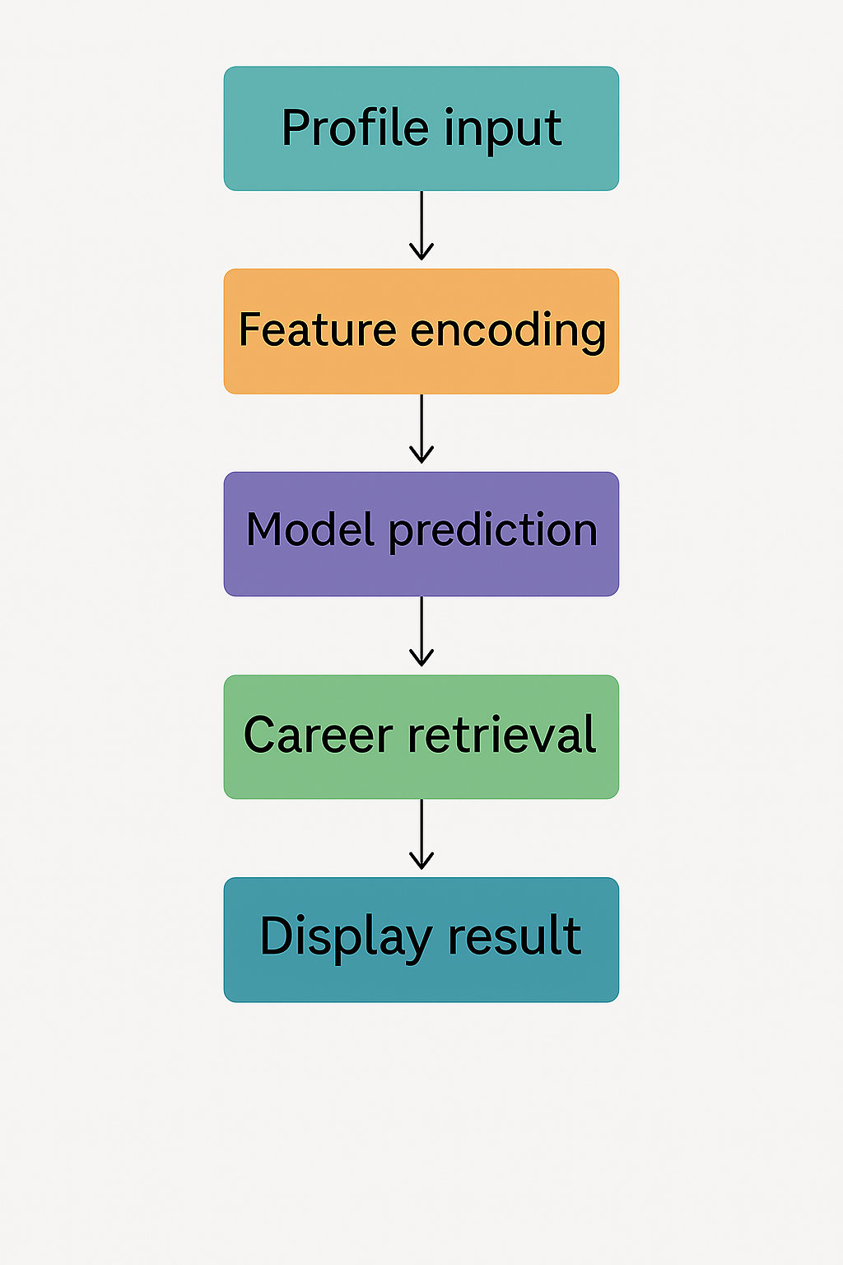

Fig 3.1: Flow Chart for Proposed Syste
3.4 Architecture:

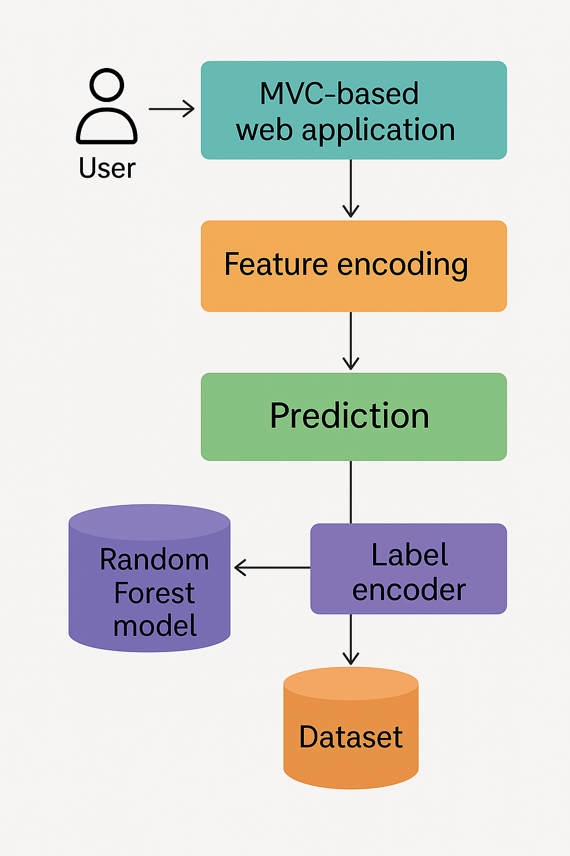

Fig 3.2: Architecture

4. SOFTWARE AND HARDWARE REQUIREMENTS

  - Software Specifications:

- The software components required for developing and executing the Automated Career Counselling System are as follows:
- Operating System: Windows 10 or higher / Ubuntu 20.04 or higher
- Programming Language: Python 3.8 or higher
- Web Framework: Flask (for building the web application)
- Machine Learning Libraries:
- scikit-learn (for Random Forest model, preprocessing, and evaluation)
- pandas (for data manipulation and analysis)
- numpy (for numerical operations)
- pickle (for model and encoder serialization)
- Web Technologies:
- HTML5 and CSS3 (for frontend design)
- Bootstrap 5 (for responsive styling and layout)
- Jinja2 (Flask templating engine for dynamic content rendering)
- IDE / Code Editor: Visual Studio Code / Jupyter Notebook / PyCharm
- Browser Support: Google Chrome, Mozilla Firefox, Microsoft Edge
- Other Tools:
- Anaconda (optional - for managing packages and environments)
- Git (for version control and collaborative development)
- These tools and libraries together ensure a smooth workflow from data preprocessing and model training to web deployment and result visualization

  - Hardware Specifications:

- The hardware requirements for implementing and running the Automated Career Counselling system are:
- Processor: Intel Core i5 or above / AMD Ryzen 5 or above
- RAM: Minimum 8 GB (recommended: 16 GB for smoother model training and multitasking)
- Storage: Minimum 256 GB SSD or 500 GB HDD
- Graphics: Integrated GPU is sufficient (No dedicated graphics required)
- Display: 13” or larger monitor with a resolution of at least 1366x768
- Input Devices: Standard keyboard and mouse
- Camera (optional): For future extensions like voice or video-based inputs
- Network: Stable internet connection (required for downloading packages or hosting web-based interfaces locally or on a cloud)
- These hardware resources ensure efficient model training, smooth execution of the Flask-based web application, and fast user interactions on both development and deployment environments.

5.SYSTEM DESIGN

Input Design:

The Input Design of the system is crucial for collecting accurate user data required for career prediction. This system uses a web-based form that is simple, user-friendly, and structured to gather all necessary features for the model. The input is collected through dropdowns, number fields, and text boxes, ensuring that user interaction is seamless and error-free.
- The system requires the following inputs:
- GPA – Entered as a decimal value (e.g., 3.5)
- Number of Internships – Integer input reflecting work exposure
- Number of Projects – Integer input indicating technical engagement
- Coding Skills – Selected from a dropdown (e.g., Beginner, Intermediate, Advanced)
- Communication Skills – Dropdown input (e.g., Poor, Average, Good, Excellent)
- Leadership Experience – Dropdown input (e.g., None, Some, Significant)
- Extracurricular Activities – Integer input representing involvement beyond academics
- Preferred Work Environment – Dropdown input (e.g., Corporate, Research, Startup)
Once validated, the inputs are preprocessed and encoded using LabelEncoder before being fed to the Random Forest classifier, ensuring compatibility with the model’s training format. The system design ensures a balance between ease of use, accuracy, and robustness, forming the foundation for reliable career prediction.

Output Design:

The Output Design of the system focuses on presenting the predicted career path in a clear, concise, and user-friendly format. After processing the input data through the Random Forest model, the system generates a career prediction, which is then dynamically rendered on the result page of the web interface.

Key Features of the Output Design:

Prediction Display:

The predicted career (e.g., Data Scientist, AI Specialist, Software Engineer) is shown prominently in a styled output box using HTML and CSS.

Dynamic Rendering:

Flask with Jinja2 templating is used to inject the model’s output into the predict.html page, ensuring real-time and seamless result delivery.

User Guidance:

A “Try Again” button is provided, allowing users to go back to the input form and submit different profiles for analysis, enhancing interactivity.

Styling and Layout:

Results are shown in a centered container with modern CSS design including borders, shadows, and padding.

The predicted career is styled using larger font size and highlighted color (#007bff) to draw immediate attention.

Responsiveness:

Output pages are fully responsive, adapting to various screen sizes including desktops, laptops, tablets, and mobile devices using Bootstrap.

Example Output Behavior:

If a career is predicted:

"Your predicted career is: AI Specialist".

UML Diagrams:
Unified Modeling Language (UML) diagrams are used to visually represent the architecture and behavior of the system. In this project, UML diagrams illustrate how different components of the career prediction system interact, how data flows through the model, and how the user interacts with the interface. These diagrams provide a blueprint of the system’s design, improving clarity during development and aiding in communication among team members. The diagrams include Use Case Diagram, Class Diagram, Sequence Diagram, Activity Diagram, Component Diagram, Deployment Diagram, and Data Flow Diagram (DFD).

5.4 Use Case Diagram:

The Use Case Diagram illustrates the interaction between the User and the Career Prediction System. The primary actor is the user, who inputs academic and skill-related data through a web interface. The system processes this data, performs encoding, invokes the trained Random Forest model, and generates the most suitable career path. The main use cases include: Submit Profile Details, Process Input, Predict Career, and Display Result. This diagram helps in understanding how the user and system components communicate to fulfill the core objective of career counselling.

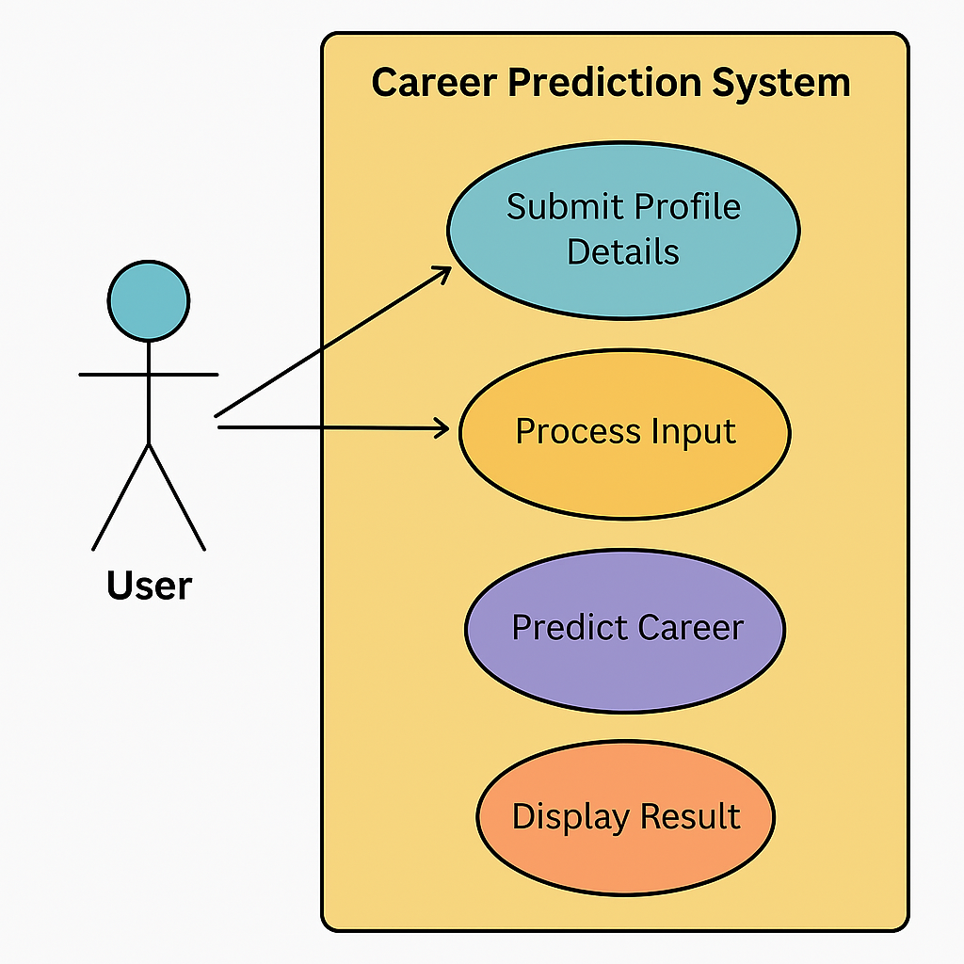
Fig 5.1: Use Case Diagram for System & Use

Class Diagram:

The Class Diagram for the Automated Career Counselling System outlines the core components involved in model training, prediction, and user interaction. The key classes include DataPreprocessor, responsible for loading the dataset, encoding categorical features using LabelEncoder, and preparing the data for model training; ModelTrainer, which handles the training of the Random Forest classifier, evaluating accuracy, and saving the model and encoders; and CareerPredictor, which loads the saved model and encoders and makes predictions based on new user input. Another class, AppUI, manages the Flask-based web interface to receive user input and return predictions. Each class has attributes for its data and methods for performing its operations, ensuring a modular and maintainable structure.

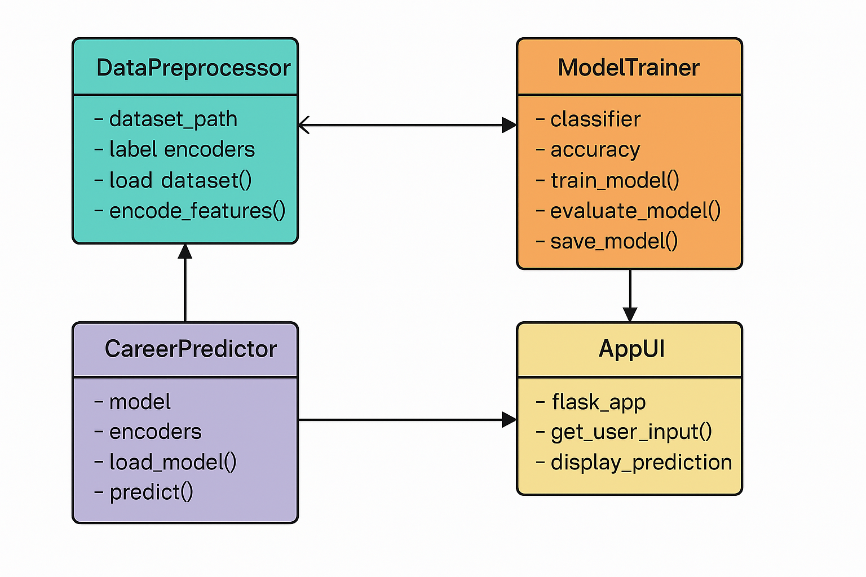
Fig 5.2: Class Diagram

5.6 Sequence Diagram:

The Sequence Diagram illustrates the step-by-step interaction among various components involved in predicting a career. The process begins when the User submits their profile data via the web interface. The AppUI (Flask Application) receives this input and forwards it to the CareerPredictor module. This module encodes the features using the LabelEncoder and loads the Random Forest Model to predict the appropriate career path. The predicted career is then returned to the AppUI, which renders it back on the result page for the user. This diagram showcases the real-time data flow and time-sequenced communication between components, ensuring seamless prediction and response.

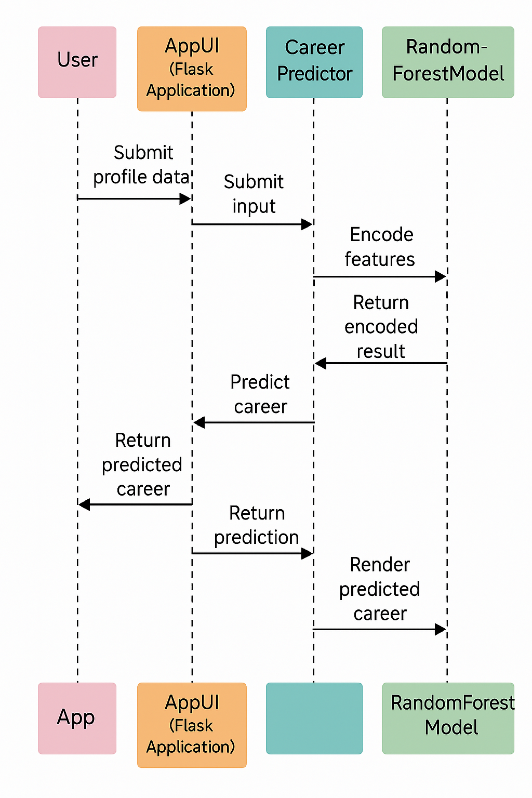

Fig 5.3: Sequence Diagram for User & System

5. 7 Collaboration Diagram:

The Collaboration Diagram for this system highlights the structural organization and interaction among objects during the career prediction process. The primary objects involved include User, Flask App Interface (AppUI), Career Predictor, Label Encoder, and the Random Forest Model. When a user submits input, the AppUI object forwards it to the Career Predictor, which interacts with the Label Encoder to transform categorical values and with the Random Forest Model to generate the prediction. The result is then returned through the AppUI to the user. This diagram emphasizes both the flow of messages and the relationships among objects in the system.

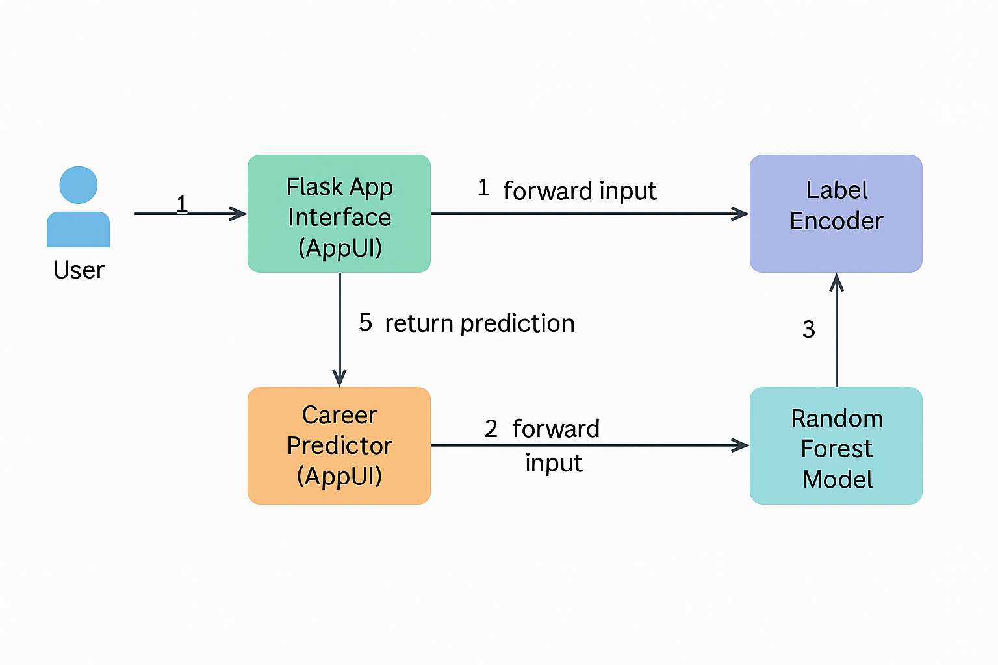

Fig 5.4: Collaboration Diagram

5. 8 Deployment Diagram:

The deployment diagram for the RAG Bot system illustrates the physical architecture and component interaction in an offline environment. The system consists of three main nodes: the User Device, the Web Server, and the Model Server. The user interacts with the application through a browser on their device, which communicates with a Flask-based Web Server that handles document upload, query processing, and response rendering. The Web Server processes these inputs and communicates with the Model Server, where pre-trained AI models (e.g., model.pkl or transformer models) are stored and executed to generate context-aware answers. All components are deployed locally, ensuring complete offline functionality, secure data handling, and fast processing without reliance on external APIs or internet access.
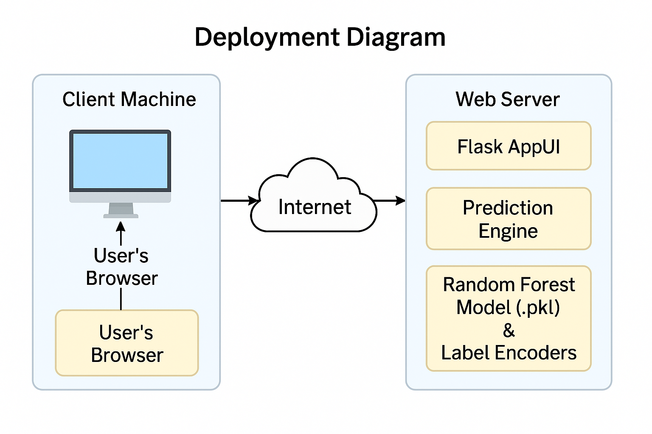
Fig 5.5: Deployment Diagram

5.9 Activity Diagram:

The Activity Diagram outlines the step-by-step flow of operations in the system from the user's perspective to backend processing. The user begins by accessing the web application and filling in their profile details such as GPA, skills, and preferences. Once submitted, the system validates and encodes the input data. This processed data is passed to the Random Forest prediction model, which generates the most suitable career path based on the input. The result is then displayed back to the user on the interface. The diagram visually maps this sequential flow using activities, decision points, and arrows to represent transitions, providing a clear understanding of how the system functions end-to-end.
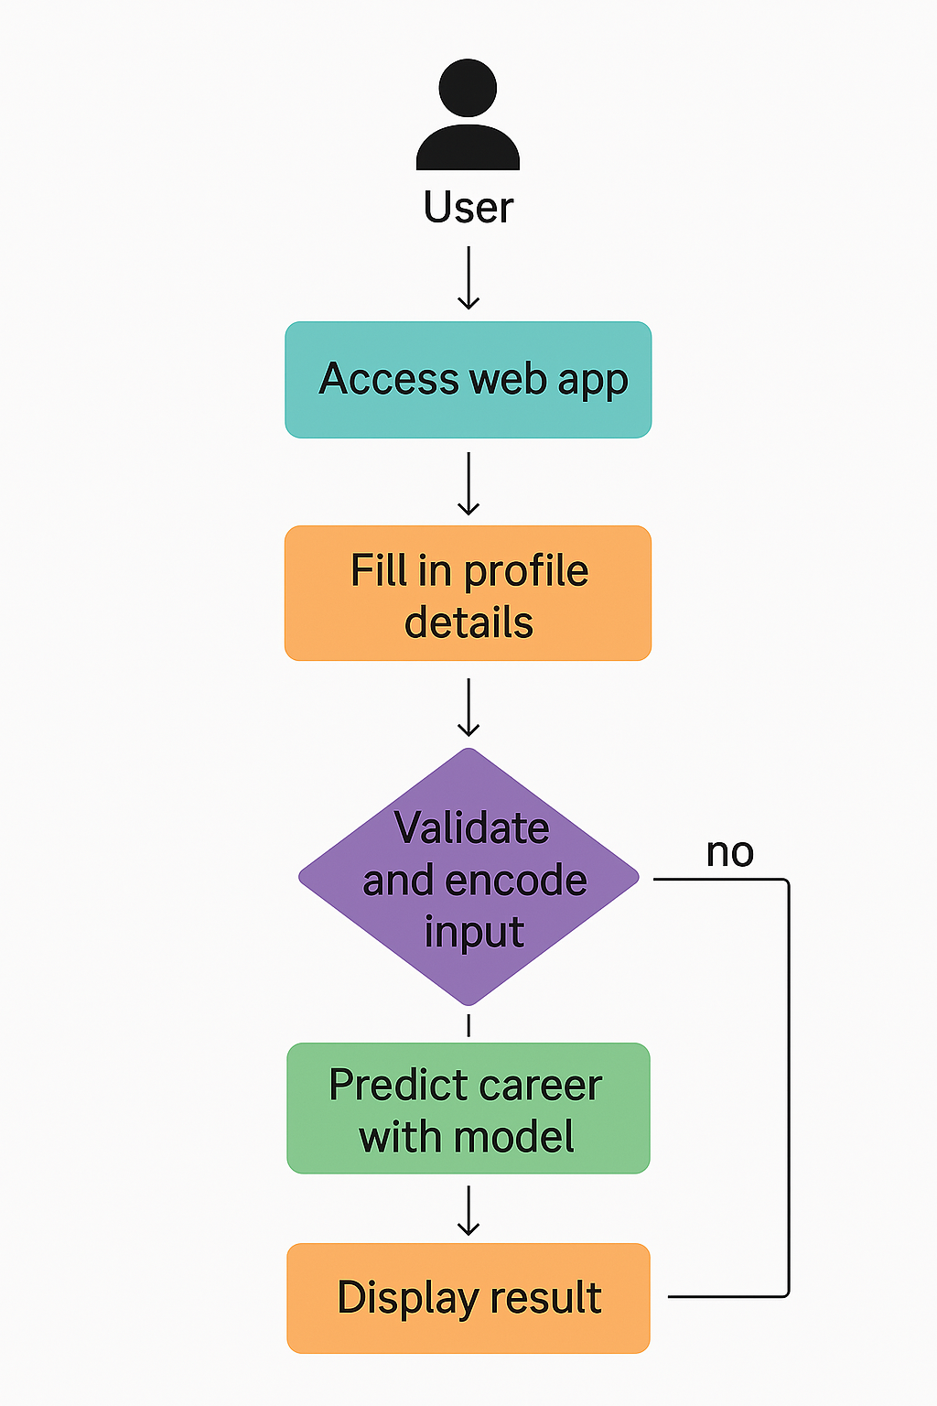
Fig 5.6: Activity Diagram

5.10 Component Diagram:

The Component Diagram represents the modular structure of the system and illustrates the key components involved in the career prediction process. The main components include the User Interface Module, which consists of index.html and predict.html files that handle input and output presentation. The Flask App Controller serves as the backbone of the application, managing HTTP routes and request handling. The Prediction Engine component loads the pre-trained Random Forest model and label encoders, processes user data, performs feature transformation, and returns the predicted result. These components interact with external resources like the Dataset Module and Model Files (.pkl) to ensure accurate and real-time prediction. Each component is connected using interfaces, reflecting the high cohesion and loose coupling architecture, ideal for scalability and maintainability.
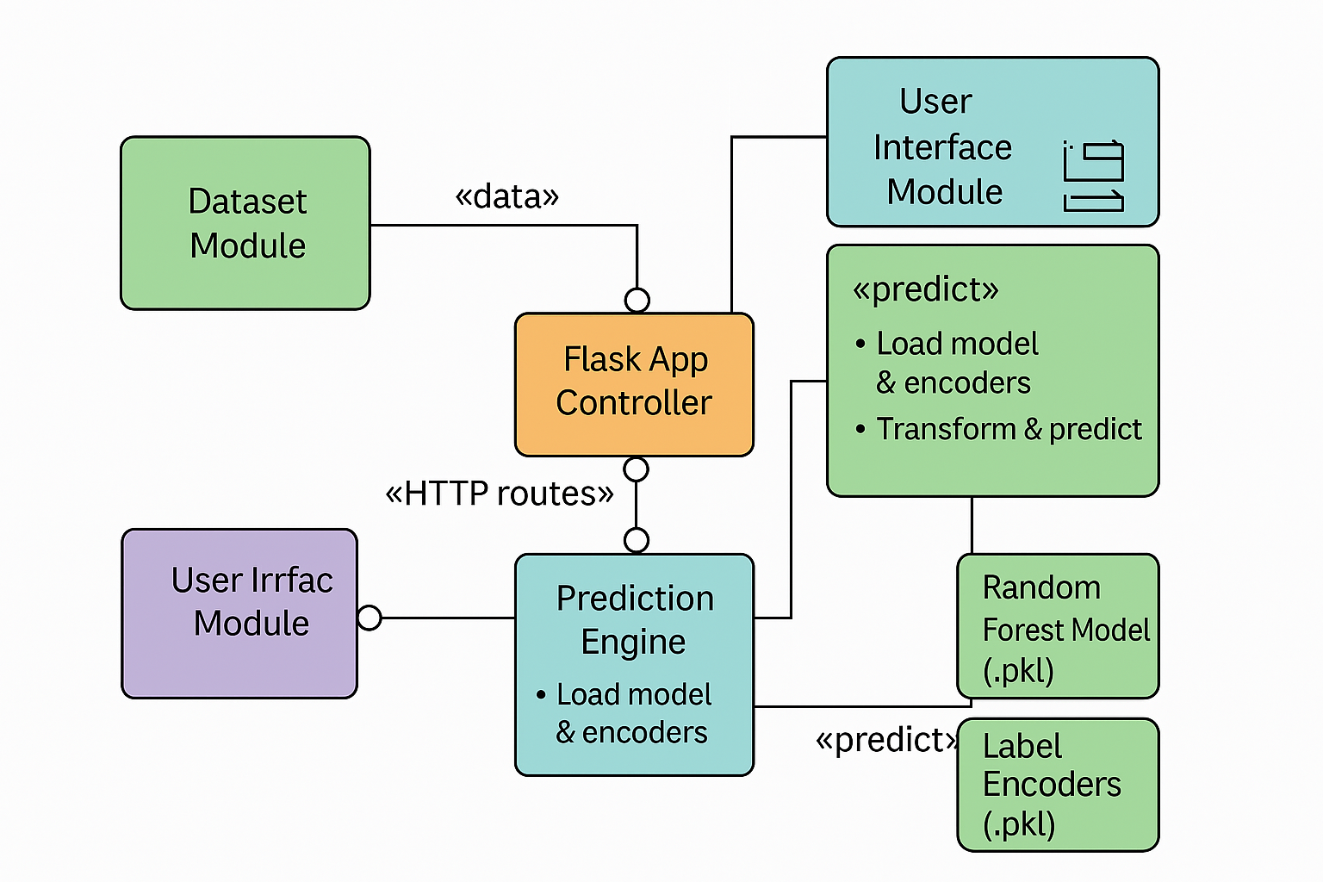

Fig 5.7: Component Diagram

5.11 ER Diagram:

The ER Diagram represents the logical structure of the data used in the system. It includes entities such as Candidate, Skills, Projects, Internships, and Predicted_Career. The Candidate entity holds attributes like Candidate_ID, GPA, and Preferred_Work_Environment. It is associated with multiple Projects, Internships, and Skills, where each skill includes Skill_Type and Skill_Level. The Predicted_Career entity stores the career outcome mapped to each candidate. Relationships like “Has”, “Completed”, and “Mapped_To” connect these entities, reflecting how user profiles are constructed and how predictions are linked to them. This model helps in structuring the dataset effectively and aligns with the schema used for training and prediction.

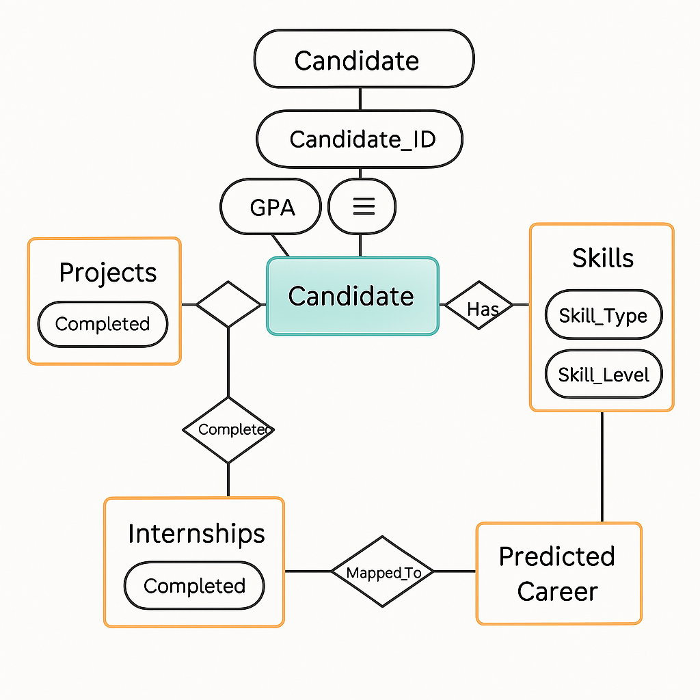
Fig 5.8: ER Diagram

DFD Diagram:

The Data Flow Diagram (DFD) illustrates how data moves through the system, showing the transformation from user input to career prediction output. The process begins when the User submits their profile data through the web interface. This data is received by the Input Processor, which cleans and formats the input before sending it to the Encoding Module. The Encoded Data is passed to the Prediction Engine, which interacts with the Random Forest Model (.pkl) to generate a prediction. The result is routed back to the

Web Output Handler, which displays the predicted career to the user. External files like the Label Encoders and Dataset Repository are also involved for preprocessing and learning. The DFD captures both the logical flow and system dependencies, highlighting a clear and structured data movement architecture.
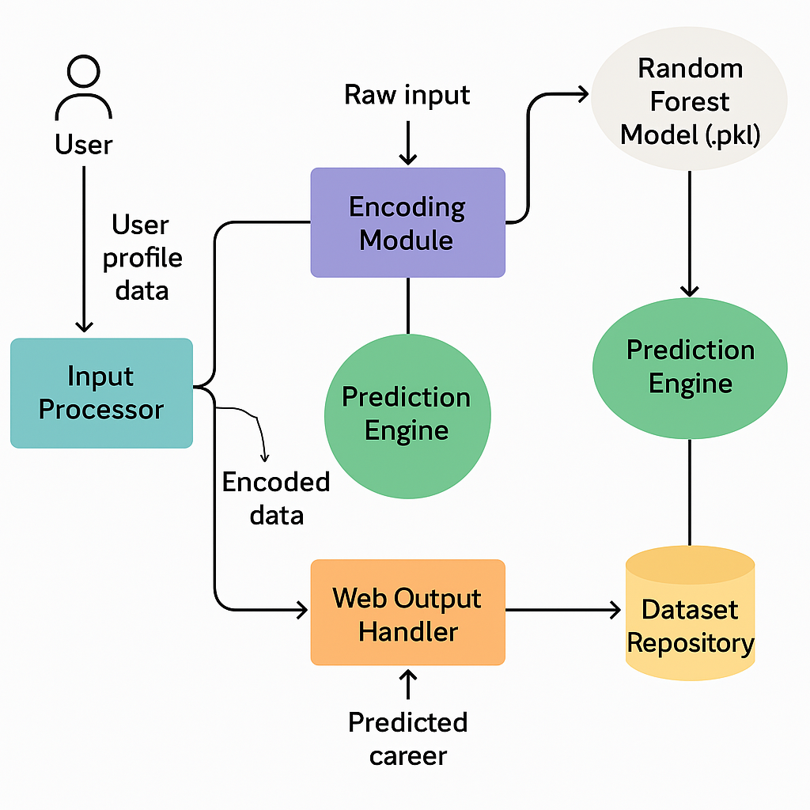
Fig 5.9: DFD Diagram

6.MODULE IMPLEMENTATION

6.1 User:

The system follows a modular implementation strategy to ensure clarity, reusability, and ease of maintenance. Each module is responsible for a specific aspect of the system’s functionality, from data handling to machine learning and user interaction.

The Dataset Module plays a foundational role in the project. It contains the structured data (Career_Prediction_Modified.csv) required for training the prediction model. This dataset includes essential fields such as GPA, internships, projects, coding skills, communication skills, leadership experience, extracurricular activities, and preferred work environment. The target variable is the “Career” field, which the model learns to predict based on these features.

The Data Preprocessing Module is responsible for preparing the data for machine learning. It encodes categorical values using the LabelEncoder from the scikit-learn library and separates features from the target column. This ensures the dataset is properly formatted and all input attributes are numerically encoded, allowing for compatibility with the Random Forest algorithm.

The Model Training Module, implemented in model.py, trains a Random Forest Classifier using the preprocessed dataset. The module splits the data into training and test sets, fits the model to the training data, and evaluates it using accuracy score. After successful training, the model and corresponding encoders are saved in .pkl files using Python’s pickle module, ensuring that the model can be reused without retraining.

6.2 System:

The Prediction Module is handled in app.py, which serves as the backend controller. It loads the trained model and label encoders and accepts new input from users through a web form. The module encodes the incoming data using saved encoders and feeds it to the Random Forest model to generate a prediction. The predicted label is then mapped back to its corresponding career name and sent back to the frontend for display.

The Flask Web Application Module (AppUI) provides an intuitive and responsive user interface. Implemented using HTML, CSS, and Bootstrap within index.html and predict.html, it allows users to enter their profile details and view predicted career outcomes. Flask handles routing and renders the prediction result using the Jinja2 templating engine. The user experience is enhanced through a clean layout and structured form inputs.

Lastly, the Model Storage Module includes model.pkl and label_encoders.pkl, which store the trained machine learning model and the corresponding label encoders. These serialized files are loaded during runtime to perform real-time predictions without the need for retraining, ensuring efficiency and scalability.

Together, these modules work seamlessly to create a fully functional automated career counselling system, offering users quick and reliable predictions based on their academic and personal profile.

6.3: Algorithm:

The algorithm used in this project is the Random Forest Classifier, which is an ensemble machine learning technique widely known for its high accuracy and robustness. It operates by constructing a multitude of decision trees during training time and outputs the class that is the mode of the classes (classification) or mean prediction (regression) of the individual trees. This method helps in overcoming the limitations of a single decision tree, such as overfitting, by introducing diversity through random sampling and feature selection.

Random Forest works on the principle of Bagging (Bootstrap Aggregation). In this process, multiple subsets of the dataset are generated using random sampling with replacement. A decision tree is trained on each subset independently, using a random subset of features at each split, which introduces variation and reduces correlation among the trees. When a new input is given, each tree in the forest gives a classification result, and the final output is determined by a majority vote from all the decision trees.

In this project, the Random Forest Classifier is trained using student profile data, which includes both numerical and categorical features. The categorical data (such as communication skills or work environment preferences) is encoded using LabelEncoder to convert it into a format suitable for training. The model then learns to associate patterns in the input data with a particular career path based on the labeled dataset provided.

Once trained, the model is saved as a .pkl file and can be reused for making predictions in real-time. When a user submits their profile through the web interface, the input is processed and passed to the Random Forest model, which quickly analyzes the input feature set and predicts the most suitable career. The efficiency and high generalization performance of Random Forest make it an ideal choice for this kind of career.

7. SOURCE CODE

APP.PY
from flask import Flask, request, render_template, jsonify
import pickle
import pandas as pd

app = Flask(__name__, template_folder=r"D:\Career\Careerprediction\templates")

# Load the trained model
model = pickle.load(open(r'D:\Career\Careerprediction\Model\model.pkl', 'rb'))
label_encoders = pickle.load(open(r'D:\Career\Careerprediction\Model\label_encoders.pkl', 'rb'))

le = label_encoders["Career"]
career_classes = dict(zip(le.transform(le.classes_), le.classes_))

@app.route('/')
def index():
return render_template("index.html")

@app.route('/predict', methods=['POST'])
def predict():
try:
# Get form data directly as integers/floats
data = request.form
print("📥 Received Input Data:", data) # Debugging

encoded_data = {
"GPA": float(data["GPA"]),
"Internships": int(data["Internships"]),
"Projects": int(data["Projects"]),
"Coding_Skills": int(data["Coding_Skills"]),
"Communication_Skills": int(data["Communication_Skills"]),
"Leadership_Experience": int(data["Leadership_Experience"]),
"Extracurricular_Activities": int(data["Extracurricular_Activities"]),
"Preferred_Work_Environment": int(data["Preferred_Work_Environment"])
}

print("🛠️ Encoded Data for Model:", encoded_data) # Debugging

# Convert into DataFrame for model prediction
df = pd.DataFrame([encoded_data])
print(df)
# Make prediction
print(model.predict(df)[0])
prediction = model.predict(df)[0]

career = ""
if prediction in career_classes:
career = career_classes[prediction]

# Render prediction result page
return render_template("predict.html", career=career)

except Exception as e:
return jsonify({'error': str(e)}), 400

if __name__ == '__main__':
app.run(debug=True)

MODEL.PY

import pandas as pd
import numpy as np
from sklearn.model_selection import train_test_split
from sklearn.ensemble import RandomForestClassifier
from sklearn.preprocessing import LabelEncoder
from sklearn.metrics import accuracy_score
import pickle

# Load the modified dataset
df = pd.read_csv(r"D:\Career\Careerprediction\Dataset\Career_Prediction_Modified.csv")

# Encode categorical features
label_encoders = {}
categorical_columns = ["Coding_Skills", "Communication_Skills", "Leadership_Experience",
"Preferred_Work_Environment", "Career"]

for col in categorical_columns:
le = LabelEncoder()
df[col] = le.fit_transform(df[col])
label_encoders[col] = le
print(f"Encoding for {col}: {dict(zip(le.classes_, le.transform(le.classes_)))}")

# Split features and target
X = df.drop(columns=["Career"])
y = df["Career"]

# Split into train and test sets
X_train, X_test, y_train, y_test = train_test_split(X, y, test_size=0.2, random_state=42)

# Fit Random Forest model
rf_model = RandomForestClassifier(n_estimators=100, random_state=42)
rf_model.fit(X_train, y_train)

# Predict on test set
y_pred = rf_model.predict(X_test)

# Calculate accuracy
accuracy = accuracy_score(y_test, y_pred)
print(f"Random Forest Accuracy: {accuracy * 100:.2f}%")

# Save the model and label encoders
pickle.dump(rf_model, open(r'D:\Career\Careerprediction\Model\model.pkl', 'wb'))
pickle.dump(label_encoders, open(r'D:\Career\Careerprediction\Model\label_encoders.pkl', 'wb'))

INDEX.HTML

<!doctype html>
<html lang="en">

<head>
<meta charset="utf-8">
<meta name="viewport" content="width=device-width, initial-scale=1">
<title>Career Prediction</title>
<link href="https://cdn.jsdelivr.net/npm/bootstrap@5.3.2/dist/css/bootstrap.min.css" rel="stylesheet">
<style>
body {
background-color: #f8f9fa;
}
.hero-section {
background: linear-gradient(to right, #1e3c72, #2a5298);
color: white;
padding: 50px 0;
}
.form-card {
background: white;
padding: 30px;
border-radius: 10px;
box-shadow: 0 4px 10px rgba(0, 0, 0, 0.1);
}
</style>
</head>

<body>
<!-- Header -->
<nav class="navbar navbar-light bg-white shadow-sm">
<div class="container">
<a class="navbar-brand d-flex align-items-center" href="/">
<span class="ms-2 fs-4 fw-bold">Career Prediction</span>
</a>
</div>
</nav>

<!-- Hero Section -->
<div class="hero-section text-center">
<h1 class="fw-bold">Predict Your Career Path</h1>
<p>Fill in the details below to get career predictions.</p>
</div>

<!-- Prediction Form Section -->
<div class="container my-5">
<div class="row justify-content-center">
<div class="col-lg-6 col-md-8">
<div class="form-card">
<h2 class="text-center text-primary">Career Prediction Form</h2>
<form action="/predict" method="post">
<div class="mb-3">
<label for="GPA" class="form-label">GPA</label>
<input type="number" step="0.01" min="0" max="5" class="form-control" id="GPA" name="GPA" required>
</div>
<div class="mb-3">
<label for="Internships" class="form-label">Number of Internships</label>
<input type="number" class="form-control" id="Internships" min="0" name="Internships" required>
</div>
<div class="mb-3">
<label for="Projects" class="form-label">Number of Projects</label>
<input type="number" class="form-control" min="0" id="Projects" name="Projects" required>
</div>
<div class="mb-3">
<label class="form-label">Coding Skills</label>
<select class="form-select" name="Coding_Skills" required>
<option value="1">Intermediate</option>
<option value="0">Advanced</option>
</select>
</div>
<div class="mb-3">
<label class="form-label">Communication Skills</label>
<select class="form-select" name="Communication_Skills" required>
<option value="0">Average</option>
<option value="2">Good</option>
<option value="1">Excellent</option>
</select>
</div>
<div class="mb-3">
<label class="form-label">Leadership Experience</label>
<select class="form-select" name="Leadership_Experience" required>
<option value="2">None</option>
<option value="1">Some</option>
<option value="0">Significant</option>
</select>
</div>
<div class="mb-3">
<label for="Extracurricular_Activities" class="form-label">Number of Extracurricular Activities</label>
<input type="number" class="form-control" min="0" id="Extracurricular_Activities" name="Extracurricular_Activities" required>
</div>
<div class="mb-3">
<label class="form-label">Preferred Work Environment</label>
<select class="form-select" name="Preferred_Work_Environment" required>
<option value="0">Corporate</option>
<option value="2">Startup</option>
<option value="1">Research</option>
</select>
</div>
<div class="text-center mt-4">
<button type="submit" class="btn btn-primary btn-lg">Predict Career</button>
</div>
</form>
</div>
</div>
</div>
</div>

<!-- <script src="https://cdn.jsdelivr.net/npm/bootstrap@5.3.2/dist/js/bootstrap.bundle.min.js"></script> -->
</body>

</html>

PREDICT.HTML

<!DOCTYPE html>
<html lang="en">
<head>
<meta charset="UTF-8">
<meta name="viewport" content="width=device-width, initial-scale=1.0">
<title>Career Prediction Result</title>
<style>
body {
font-family: Arial, sans-serif;
margin: 40px;
text-align: center;
}
.container {
width: 50%;
margin: auto;
padding: 20px;
border: 1px solid #ccc;
border-radius: 10px;
box-shadow: 2px 2px 10px rgba(0,0,0,0.1);
}
.result {
font-size: 22px;
font-weight: bold;
color: #007bff;
}
button {
margin-top: 20px;
padding: 10px;
background-color: #28a745;
color: white;
border: none;
border-radius: 5px;
cursor: pointer;
}
</style>
</head>
<body>
<div class="container">
<h2>Predicted Career</h2>
<p class="result" id="career-result">
{% if career|length == 0 %} No prediction found!
{% else %} Your predicted career is: {{career}}
{% endif %}
</p>
<button onclick="goBack()">Try Again</button>
</div>

<script>
function goBack() {
window.location.href = "/";
}

</script>
</body>
</html>

8.SYSTEM TESTING

The purpose of testing is to discover errors. Testing is the process of trying to discover every conceivable fault or weakness in a work product. It provides a way to check the functionality of components, sub-assemblies, assemblies and/or a finished product
Software system meets its requirements and user expectations and does not fail in an unacceptable manner. There are various types of test. Each test type addresses a specific testing requirement.
  - : Types Of Tests 8.1.1: Unit Testing:
Unit testing involves the design of test cases that validate that the internal program logic is functioning properly, and that program inputs produce valid outputs. All decision branches and internal code flow should be validated. It is the testing of individual software units of the application .it is done after the completion of an individual unit before integration. This is a structural testing, that relies on knowledge of its construction and is invasive. Unit tests perform basic tests at component level and test a specific business process, application, and/or system configuration. Unit tests ensure that each unique path of a business process performs accurately to the documented specifications and contains clearly defined inputs and expected results.
      - : Integration Testing:

Integration tests are designed to test integrated software components to determine if they actually run as one program. Testing is event driven and is more concerned with the basic outcome of screens or fields. Integration tests demonstrate that although the components were individually satisfaction, as shown by successfully unit testing, the combination of components is correct and consistent. Integration testing is specifically aimed at exposing the problems that arise from the combination of components.

    - Functional Testing:

Functional tests provide systematic demonstrations that functions tested are available as specified by the business and technical requirements, system documentation, user manuals.

Functional testing is centered on the following items:

Valid Input : identified classes of valid input must be accepted. Invalid Input : identified classes of invalid input must be rejected. Functions : identified functions must be exercised.
Output : identified classes of application outputs must be exercised. Systems/Procedures: interfacing systems or procedures must be invoked.
Organization and preparation of functional tests is focused on requirements, key functions, or special test cases. In addition, systematic coverage pertaining to identify Business process flows; data fields, predefined processes, and successive processes must be considered for testing. Before functional testing is complete, additional tests are identified and the effective value of current tests is determined.

    - System Testing:

System testing ensures that the entire integrated software system meets requirements. It tests a configuration to ensure known and predictable results. An example of system testing is the configuration-oriented system integration test. System testing is based on process descriptions and flows, emphasizing pre-driven process links and integration points.
8.1.4.0: White Box Testing:

White Box Testing is a testing in which in which the software tester has knowledge of the inner workings, structure and language of the software, or at least its purpose. It is purpose. It is used to test areas that cannot be reached from a black box level.

8.1.4.1: Black Box Testing:

Black Box Testing is testing the software without any knowledge of the inner workings, structure or language of the module being tested. Black box tests, as most other kinds of tests, must be written from a definitive source document, such as specification or requirements document, such as specification or requirements document. It is a testing in which the software under test is treated, as a black box .you cannot “see” into it. The test provides inputs and responds to outputs without considering how the software works.
  - Unit Testing:

Unit testing is usually conducted as part of a combined code and unit test phase of the software lifecycle, although it is not uncommon for coding and unit testing to be conducted as two distinct phases.
Test strategy and approach:

Field testing will be performed manually and functional tests will be written in detail.
    - : Test objectives:
- All field entries must work properly.

- Pages must be activated from the identified link.

- The entry screen, messages and responses must not be delayed.

    - : Features to be tested:
- Verify that the entries are of the correct format

- No duplicate entries should be allowed

- All links should take the user to the correct page.

  - : Integration Testing:

Software integration testing is the incremental integration testing of two or more integrated software components on a single platform to produce failures caused by interface defects.
The task of the integration test is to check that components or software applications,
e.g. components in a software system or – one step up – software applications at the company level – interact without error.
  - Acceptance Testing:

User Acceptance Testing is a critical phase of any project and requires significant participation by the end user. It also ensures that the system meets the functional requirements.

9.OUTPUT SCREENSHOTS

Screenshot 1: Running Python File

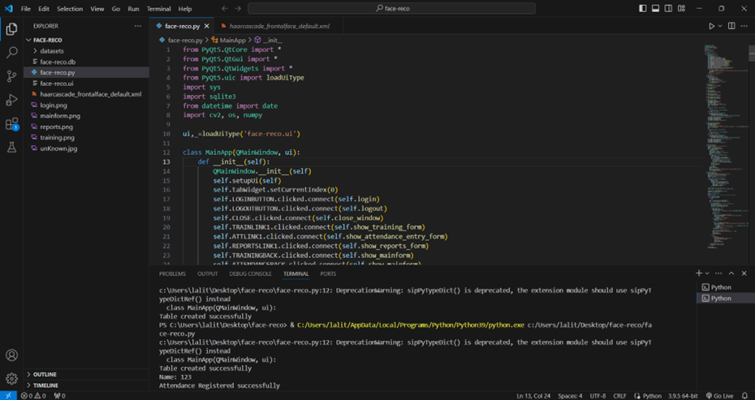

Fig 9.1: Running Python File

Screenshot 2: Home Page

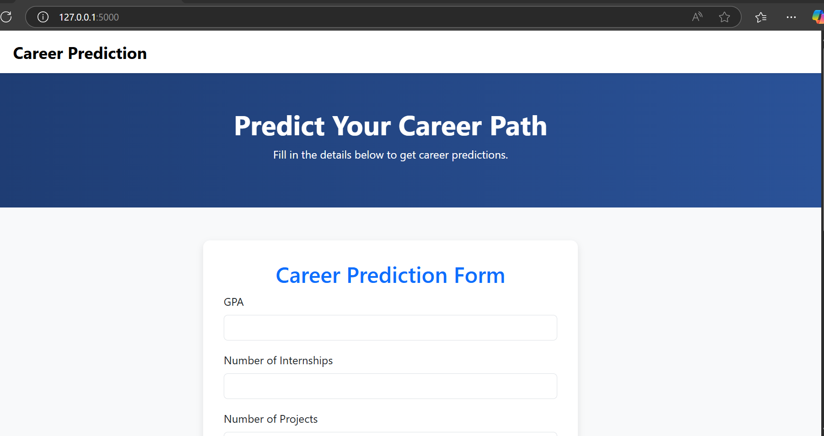

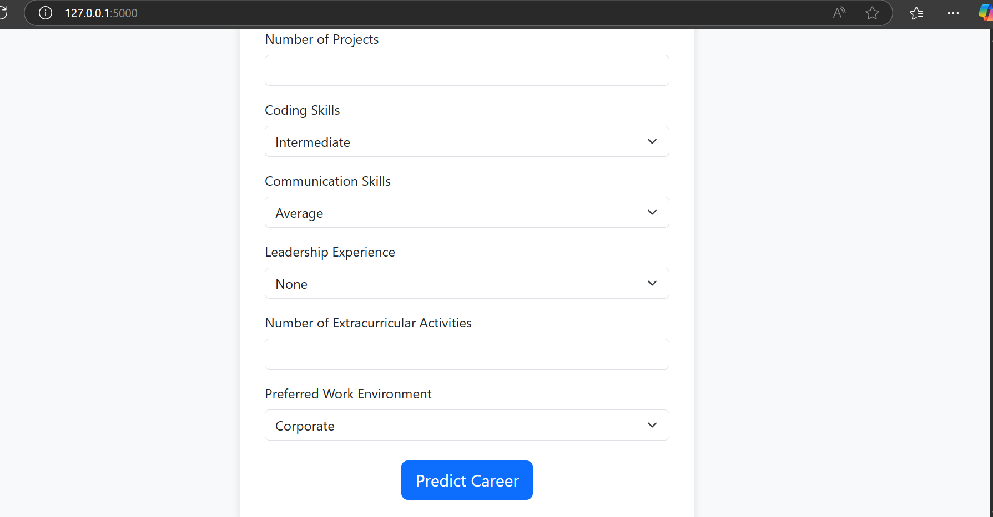

Fig 9.2: Home Page

Screenshot 3: Entering Inputs

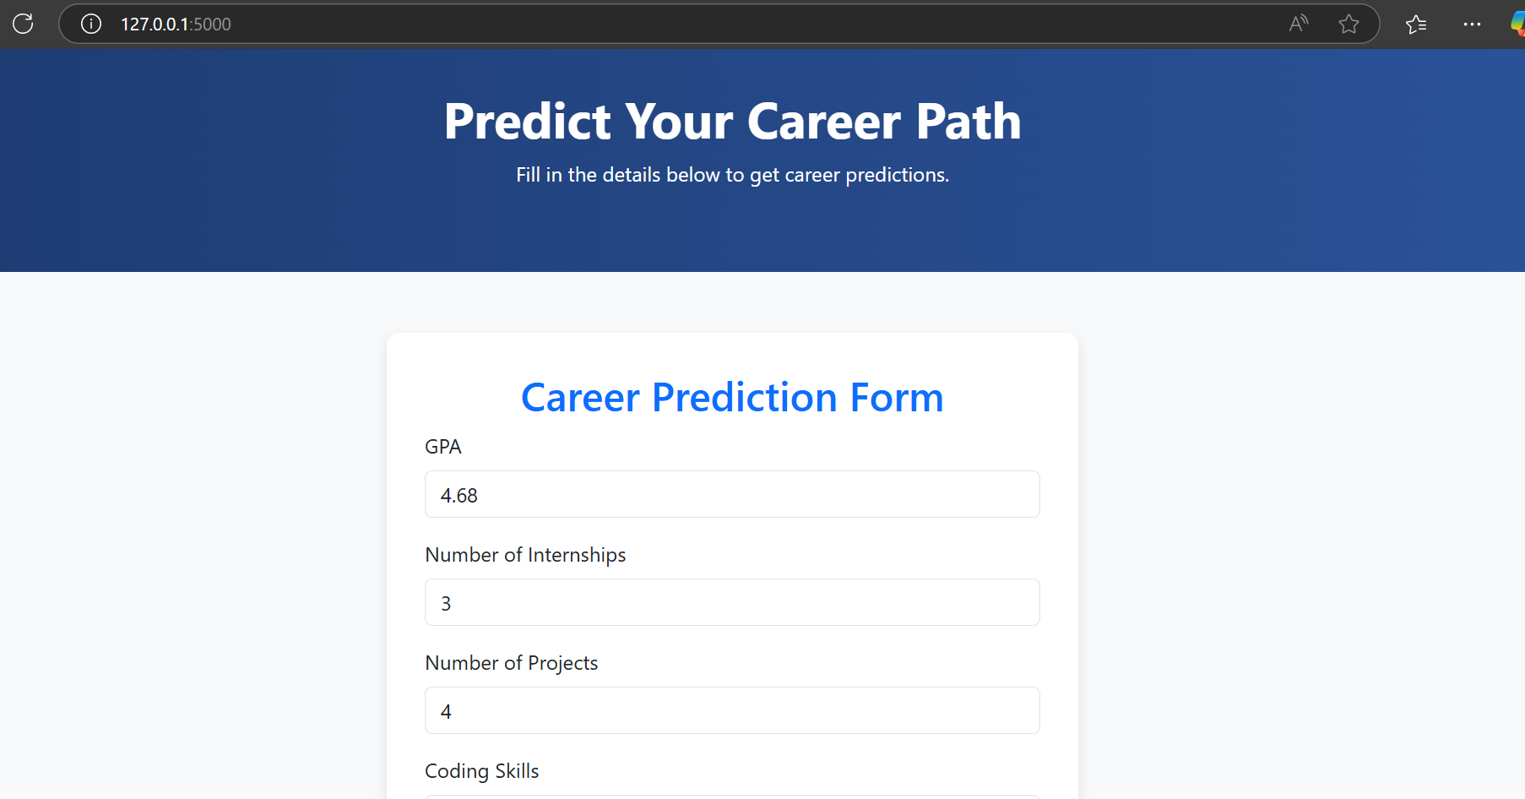

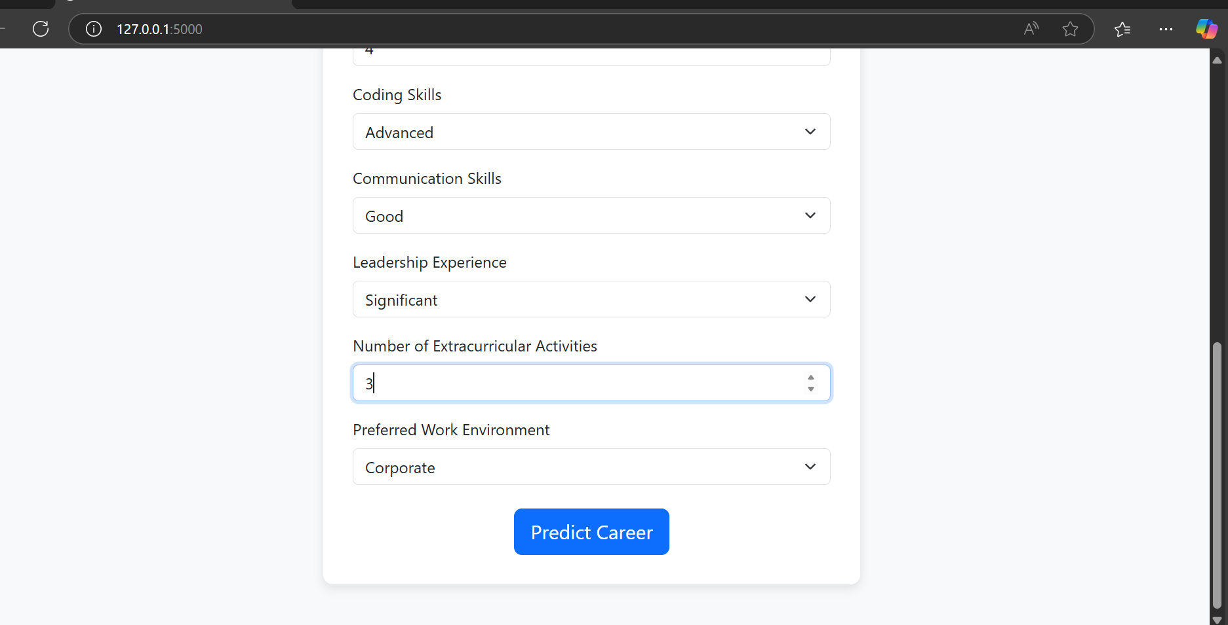

Fig 9.3: Entering Inputs

Screenshot 4: Predicted Page

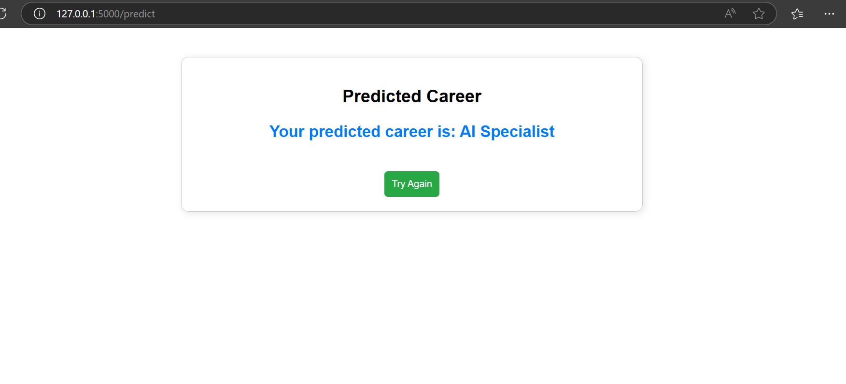

Fig 9.4: Predicted Page

10.FUTURE ENHANCEMENT

While the current system effectively predicts suitable career paths based on user input using a Random Forest Classifier, there are several opportunities for future enhancement to increase its accuracy, usability, and scalability. One major area of improvement is dataset enrichment. Incorporating more diverse and detailed input features such as academic transcripts, standardized test scores, technical certifications, aptitude test results, and even personality assessments could significantly refine the prediction capability. Additionally, user behavior tracking, such as learning history or internship feedback, can be factored into future models to personalize recommendations. The system could also benefit from transitioning from traditional machine learning to advanced deep learning models, like neural networks or hybrid ensemble techniques, which can better handle complex patterns and relationships in large datasets. On the UI/UX front, implementing a mobile-friendly application or cross-platform support would enhance accessibility and reach a broader audience, including students in remote areas. Integration of voice-based input and multilingual support would make the system more inclusive for users who are not comfortable with English or typing. Moreover, enabling real-time feedback and counseling by connecting students with experts based on their predicted career can bring a human touch to the system. Another key upgrade could be the inclusion of a dashboard or analytics module where users can track their skill development, explore multiple career options, and receive continuous guidance over time. Finally, deploying the system on cloud infrastructure can ensure better scalability, performance, and data security, making it feasible for institutional or large-scale academic use. These enhancements can transform the project from a prediction tool into a comprehensive, intelligent career counseling platform..

11.CONCLUSION
The project “Automated Career Counselling Using Random Forest Algorithm” successfully demonstrates how machine learning can be leveraged to provide intelligent, data-driven guidance for students and job seekers in choosing their ideal career path. By analyzing key attributes such as academic performance, technical skills, leadership experience, and work environment preferences, the system offers a personalized career recommendation that reduces the dependency on traditional, manual counseling methods. The use of the Random Forest algorithm ensures high accuracy, robustness, and the ability to handle complex, non-linear data relationships. With an intuitive and responsive Flask-based web interface, users can easily interact with the system, submit their details, and instantly receive career suggestions. The modular design, including separate components for data preprocessing, model training, prediction, and user interface, enhances the maintainability and scalability of the application. Throughout development, the system adhered to modern software practices such as the MVC architecture, enabling clear separation between logic, control, and presentation layers. While the current implementation provides a functional prototype with strong predictive capabilities, it also lays the foundation for future expansion with more sophisticated models and additional features. In conclusion, this project not only bridges the gap between technology and career guidance but also sets a precedent for integrating AI in educational and professional development systems.

12.BIBLIOGRAPHY

Scikit-learn Documentation – Provided comprehensive guidance for implementing the Random Forest algorithm, preprocessing techniques, and model evaluation methods.
Available at: https://scikit-learn.org
Python Official Documentation – Served as a reference for syntax, functions, and modules used in building both backend logic and data handling.
Available at: https://docs.python.org
Flask Framework Documentation – Used for building the web application architecture and managing routes, forms, and data handling with ease.
Available at: https://flask.palletsprojects.com
Bootstrap 5 Documentation – Assisted in designing a responsive and modern user interface for the input and output pages of the web application.
Available at: https://getbootstrap.com
Kaggle Dataset Repository – Offered inspiration for structuring and refining the career dataset used in training the machine learning model.
Available at: https://www.kaggle.com
W3Schools Tutorials – Referred for quick examples and explanations of HTML, CSS, and basic web development practices.
Available at: https://www.w3schools.com
GitHub Projects – Explored existing open-source career prediction and ML-based counseling systems to understand architecture and implementation.
Available at: https://github.com
Jupyter Notebooks – Used during the model development phase for testing code snippets, preprocessing data, and visualizing accuracy metrics.
Available at: https://jupyter.org
Research Papers on Career Guidance Systems – Studied several IEEE and Springer papers for understanding the real-world applications and challenges in AI-driven career counselling.
Sources: IEEE Xplore and SpringerLink academic libraries.
Medium Articles and Blogs – Followed several expert-written blogs on machine learning best practices, model optimization, and deployment strategies.
Available at: https://medium.com

